**Step 1** − Go to Manage Plugins.

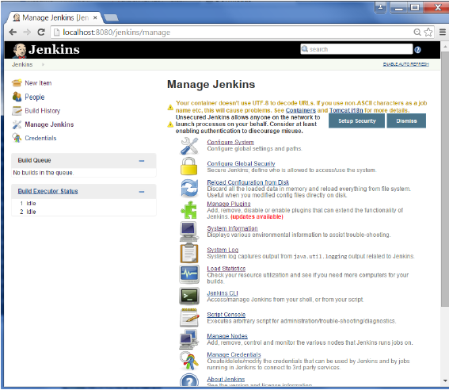

**Step 2** − Find the Hudson Selenium Plugin and choose to install. Restart the Jenkins instance.

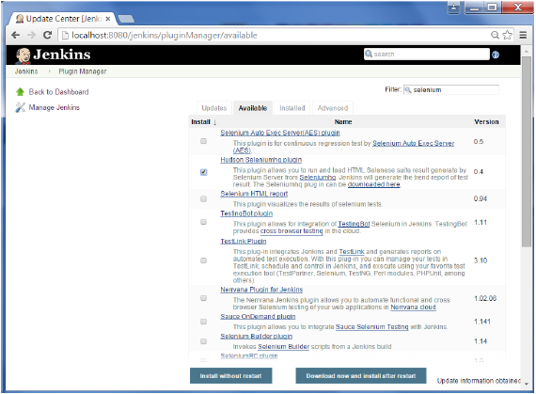

**Step 3** − Go to Configure system.

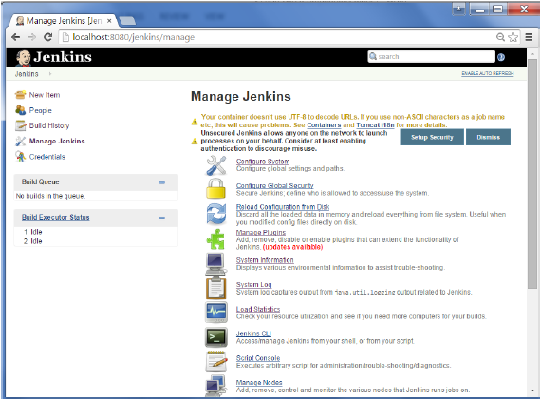

**Step 4** − Configure the selenium server jar and click on the Save button.

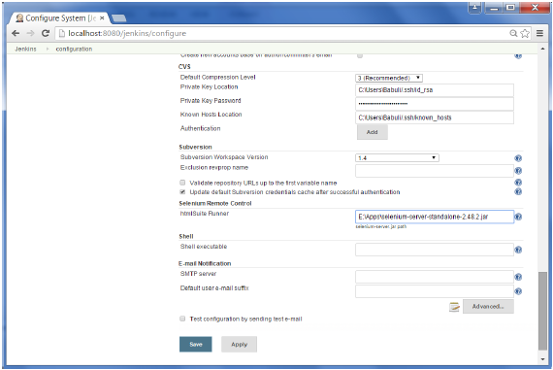

**Note** − The selenium jar file can be downloaded from the location [SeleniumHQ](http://www.seleniumhq.org/download/" \t "_blank)

Click on the download for the Selenium standalone server.

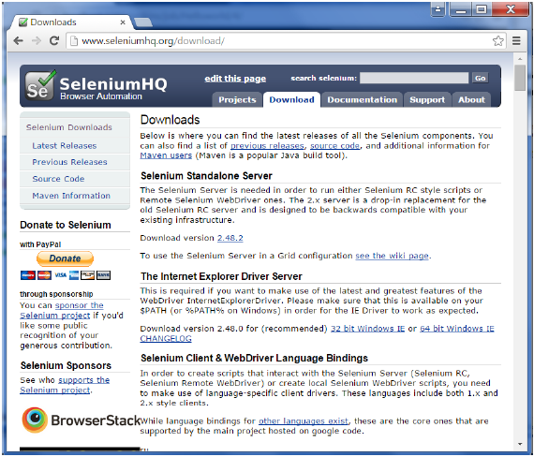

**Step 5** − Go back to your dashboard and click on the Configure option for the HelloWorld project.

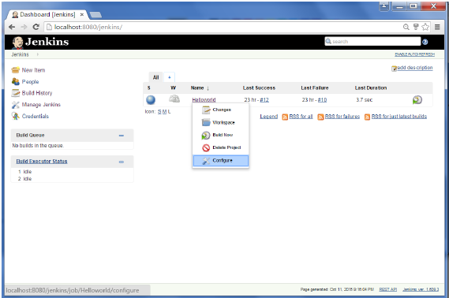

**Step 6** − Click on Add build step and choose the optin of “SeleniumHQ htmlSuite Run”

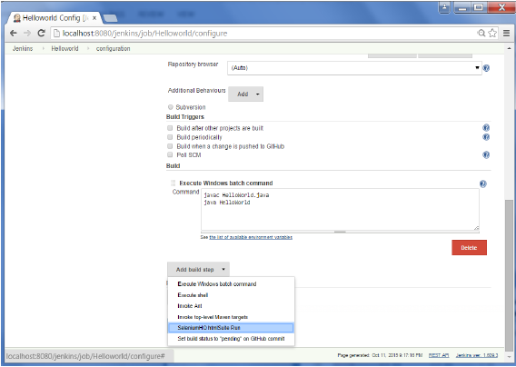

**Step 7** − Add the necessary details for the selenium test. Here the suiteFile is the TestSuite generated by using the Selenium IDE. Click on Save and execute a build. Now the post build will launch the selenium driver, and execute the html test.

